Layout Manager
By using Layout manager we can organize the components in the Frame or Applet.
Types of Layout Manager
- FlowLayout
- BorderLayout
- GridLayout
- GridBagLayout
- CardLayout

- FlowLayout
By using FlowLayout manager we can arrange the component’s in a line, one after another (in a flow). It is default layout of Panel or Applet.
Constructor
FlowLayout();
FlowLayout(int align);
FlowLayout(int align,int hgap,int vgap);
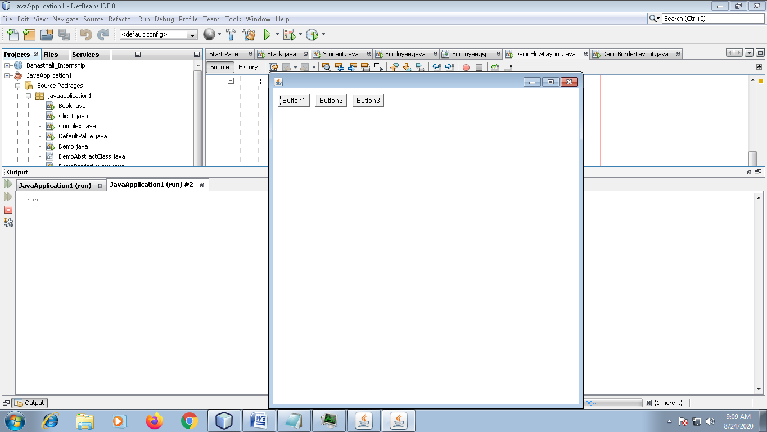

import java.awt.*;
public class DemoFlowLayout extends Frame {
Button b1,b2,b3;
Panel p1;
FlowLayout fl;
public DemoFlowLayout()
{
p1=new Panel();
fl=new FlowLayout(FlowLayout.LEFT, 10,10);
p1.setLayout(fl);

b1=new Button("Button1");
b2=new Button("Button2");
b3=new Button("Button3");
add(p1);
p1.add(b1);
p1.add(b2);
p1.add(b3);
}
public static void main(String[] args) {
DemoFlowLayout d=new DemoFlowLayout();
d.setSize(400, 600);
d.setVisible(true);
d.setLocation(500,100);
}
}
- BorderLayout
BorderLayout is used to arrange the components in five regions: east, west, north, south and center. Each region may contain one component only.
It is the by-default layout of Frame.
Constructor
BorderLayout();
BorderLayout(int hgap, int vgap);

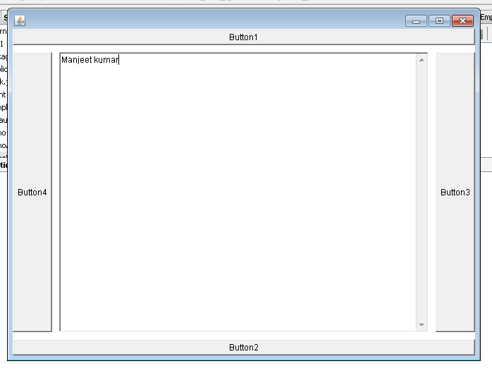

import java.awt.*;
public class DemoBorderLayout extends Frame {

Button b1,b2,b3,b4;
TextArea ta;
Panel p1;
BorderLayout bl;
public DemoBorderLayout()
{
p1=new Panel();
bl=new BorderLayout(10, 10);
p1.setLayout(bl);
b1=new Button("Button1");
b2=new Button("Button2");
b3=new Button("Button3");
b4=new Button("Button4");
ta=new TextArea(6,6);
add(p1);
p1.add("North",b1);
p1.add("South",b2);
p1.add("East",b3);
p1.add("West",b4);
p1.add("Center",ta);
}
public static void main(String[] args) {

DemoBorderLayout d=new DemoBorderLayout();
d.setSize(400, 600);
d.setVisible(true);
d.setLocation(500,100);
}

}

- Grid Layout
By using GridLayout manager we can divid the container area (Frame, Applet) into number of grids and each control you can display in one grid.
Constructor
GridLayout();
GridLayout(int rows,int cols);
GridLayout(int rows,int cols,int hgap,int vgap);

import java.awt.*;
public class DemoGridLayout extends Frame{

Label lbluid,lblpwd;
TextField txtuid,txtpwd;
Button btnLogin;
GridLayout g;
Panel p1;

public DemoGridLayout()
{
super("DemoGridLayout");
p1=new Panel();
g=new GridLayout(3,2,5,5);
p1.setLayout(g);

lbluid=new Label("Enter the User ID:");
lblpwd=new Label("Enter the Password:");
txtuid=new TextField(20);
txtpwd=new TextField(20);
btnLogin=new Button("SignIn");

add(p1);
p1.add(lbluid);p1.add(txtuid);
p1.add(lblpwd);p1.add(txtpwd);

p1.add(btnLogin);

}

public static void main(String[] args) {

DemoGridLayout d=new DemoGridLayout();
d.setSize(400, 600);
d.setVisible(true);
d.setLocation(100,200);
}

}
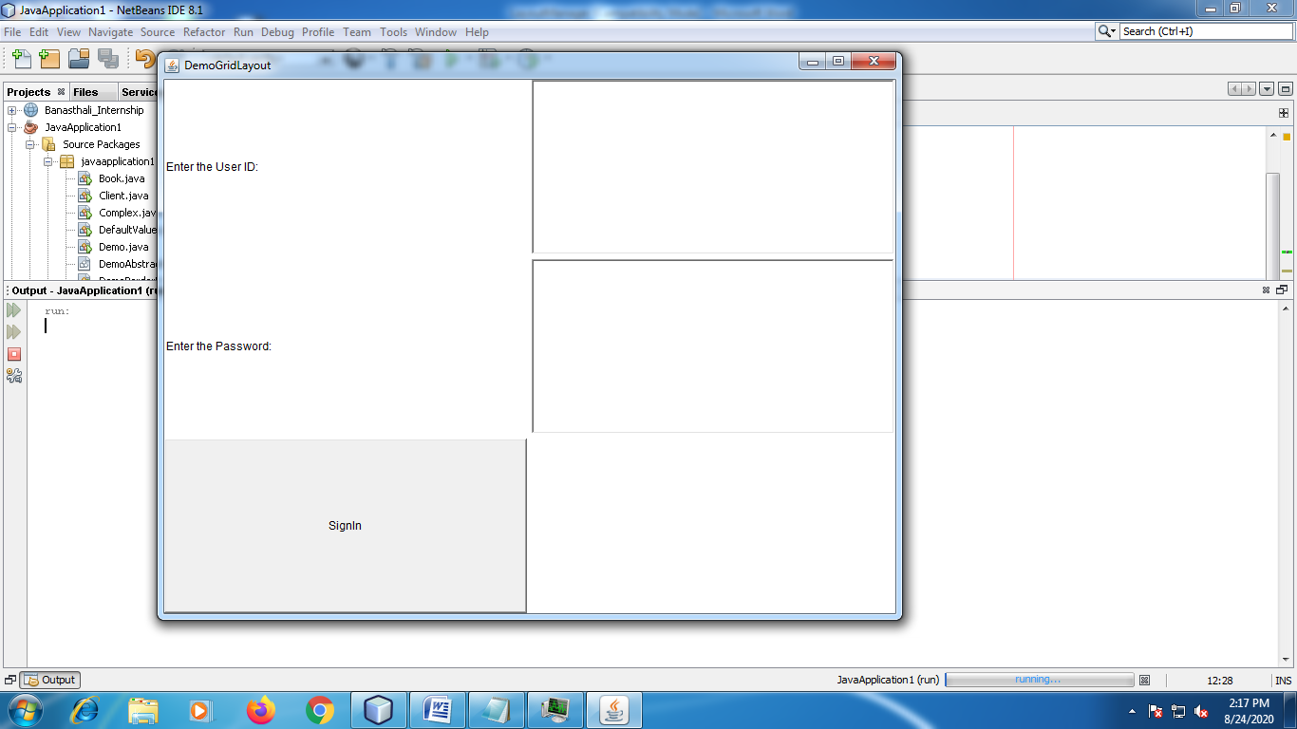

- GridBagLayout
It is complex layout manager as compared to the other layout managers. It contains the constraints
- gridx
- gridy
gridx and gridy specify the column and row at the upper left of the component. The left most column has address gridx=0 and top rows has address gridy=0.
0 0  Enter the User Id | 1 0  manjeet
0 1  Enter the Password | 1 1  manjeet
0 2  SignIn | 1 2  Clear

import java.awt.*;
public class DemoGridBagLayout extends Frame{

Label lbluid,lblpwd;
TextField txtuid,txtpwd;
Button btnLogin;
GridBagLayout g;
GridBagConstraints gc;
Panel p1;

public DemoGridBagLayout()
{
super("DemoGridBagLayout");
p1=new Panel();
g=new GridBagLayout();
gc=new GridBagConstraints();
p1.setLayout(g);

lbluid=new Label("Enter the User ID:");
lblpwd=new Label("Enter the Password:");
txtuid=new TextField(20);
txtpwd=new TextField(20);
btnLogin=new Button("SignIn");

gc.gridx=0;
gc.gridy=0;
g.setConstraints(lbluid, gc);

gc.gridx=1;
gc.gridy=0;
g.setConstraints(txtuid, gc);

gc.gridx=0;
gc.gridy=1;
g.setConstraints(lblpwd, gc);

gc.gridx=1;
gc.gridy=1;
g.setConstraints(txtpwd, gc);

gc.gridx=0;
gc.gridy=2;
g.setConstraints(btnLogin, gc);

add(p1);
p1.add(lbluid);p1.add(txtuid);
p1.add(lblpwd);p1.add(txtpwd);

p1.add(btnLogin);

}

public static void main(String[] args) {

DemoGridBagLayout d=new DemoGridBagLayout();
d.setSize(400, 600);
d.setVisible(true);

}
}
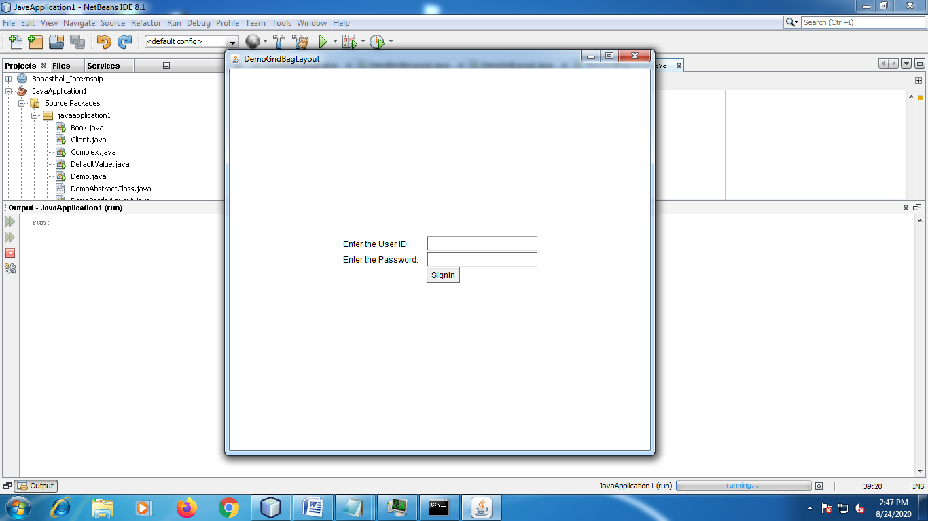

- CardLayout
CardLayout class manage the components in such a manner that only one component is visible at a time. It treats each component as a card that’s why it is known as CardLayout.
Or
You can say, by using CardLayout manager class you can create a stack of components.
public void next(Container parent)
- Flips to the next card of the specified container. If the currently visible card is the last one, this method flips to the first card in the layout.

import java.awt.*;
import java.awt.event.*;
public class DemoCardLayout extends Frame implements ActionListener{

Button b1,b2,b3;
Panel p1;
CardLayout cl;
public DemoCardLayout()
{
p1=new Panel();

cl=new CardLayout();
p1.setLayout(cl);

b1=new Button("Button1");
b2=new Button("Button2");
b3=new Button("Button3");

add(p1);
p1.add(b1);
p1.add(b2);
p1.add(b3);

b1.addActionListener(this);
b2.addActionListener(this);
b3.addActionListener(this);
}

public void actionPerformed(ActionEvent evt)
{
cl.next(p1);
}

public static void main(String[] args) {

DemoCardLayout d=new DemoCardLayout();
d.setSize(400, 600);
d.setVisible(true);

}

}

